Presented by Wells Insurance

Hurricanes are tropical cyclones that form over tropical or subtropical waters. As a result of the high winds and water they bring ashore, hurricanes can destroy or damage homes, businesses and public infrastructure, as well as cause injuries or loss of life.
An average hurricane season—from June 1 to Nov. 30—produces 14 named storms, of which seven become hurricanes and three become major hurricanes, defined as Category 3 or higher on the Saffir-Simpson Hurricane Wind Scale. However, hurricane season has been increasing in terms of both the frequency and severity of storms in recent years.
The number of severe tropical storms and hurricanes is increasing, and businesses in coastal areas are especially susceptible to their effects. According to the Congressional Budget Office, hurricane and tropical storm damages account for approximately $9 billion in losses to commercial businesses each year. What’s more, the Federal Emergency Management Agency (FEMA) found that 40% of small businesses won’t reopen following a natural disaster, and after one year, 25% more small businesses will close.
Significant portions of the United States are at risk of experiencing the effects of tropical storms and hurricanes, including the Atlantic and Gulf of Mexico coastal areas, Hawaii, parts of the Southwest, Puerto Rico, the Pacific Coast and the U.S. Virgin Islands. While the greatest threat to life and property is along the coasts due to storm surges and large waves, the impacts of hurricanes and tropical storms can be felt hundreds of miles inland. Heavy rains, strong winds, wind-driven rain, coastal and inland flooding, tornadoes and coastal storm surges can pose risks to businesses, homes and people.
While it may not be possible to prevent the occurrence of a hurricane, there are measures you can take to protect your business. This guide provides steps, preparedness methods and checklists for reducing the impact of hurricanes on your business.



In order to protect your business and its assets, it’s essential to assess who and what will be impacted in the event of a hurricane. The following should be taken into consideration when assessing the potential scope of hurricane damage:
- People—It’s essential to keep an accurate, up-to-date employee contact list. This is particularly important if many employees work remotely, as they may be scattered throughout the country and need different types of assistance when a hurricane hits. One way to keep track of employees is by implementing an emergency communication system that sends periodic notifications requiring employees to respond when they receive a message. HR can then follow up directly with any employee that doesn’t respond to verify whether their contact information has changed.
- Suppliers—Even if a hurricane does not directly damage your business, it can affect other organizations you rely on to conduct operations. For example, hurricanes have a history of causing reduced gasoline refining capacity; a shortage of drugs, medical supplies and medical devices; and food chain disruption. In addition, supply chain and travel disruptions can cause logistical issues or disrupt deliveries. When conducting your assessment, address how you’ll communicate with suppliers to account for business interruptions and potential delays.
- Locations and assets—FEMA found that many businesses never fully recover after a natural disaster, partly because of the damage to physical locations and loss of critical property and data. Many companies also struggle to withstand the financial pressures caused by extended shutdowns or limited operations. To minimize downtime after a hurricane hits, back up your data on-premises, at a remote site and in the cloud; identify a separate, more secure location where you can move physical assets to help to minimize damages; and be sure to review your disaster and flood insurance policies to ensure you meet all documentation requirements.



It’s important to have an emergency plan in place before a hurricane is predicted to understand what steps need to be taken before, during and after a storm. Consider the following:
- Be aware of the unique threats to your operational area. Businesses within 50 miles of the shoreline are at a greater risk of property damage and business interruption since they are more susceptible to storm surge flooding, extreme winds, tornadoes and inland flooding from rainfall. Protecting these locations to minimize structural and interior damage will be a higher priority than properties that are further from the coast.
- Understand what type of damage to expect from hurricane winds. The Saffir-Simpson Hurricane Wind Scale is a rating that ranges from 1 to 5 based on a hurricane’s sustained miles-per-hour (mph) wind speed and estimates potential property damage. The rating scale is as follows:
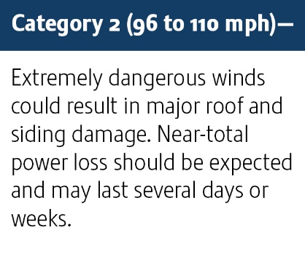
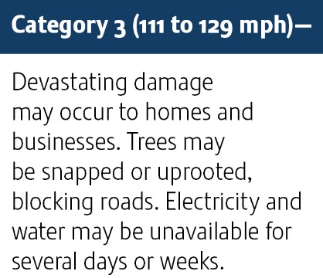
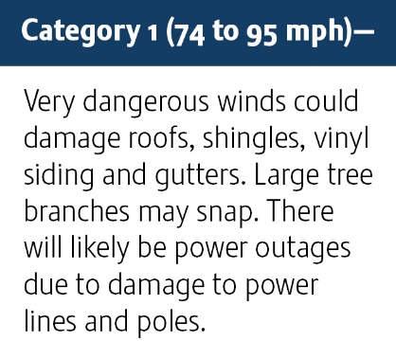

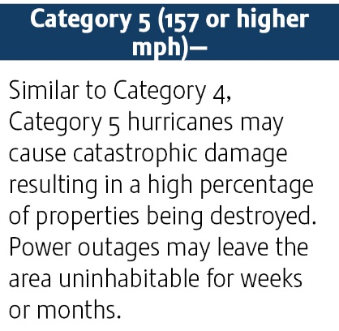
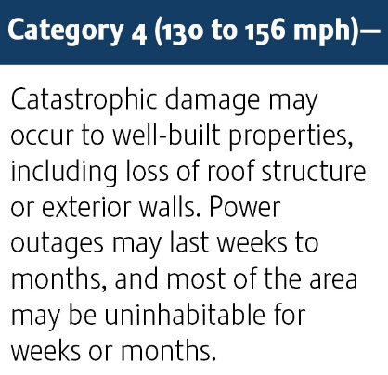

- Develop a business continuity plan. A business continuity plan establishes protocols on how your business should respond in case of an emergency or natural disaster. To prepare a business continuity plan:
  - Verify all employee, supplier and vendor contact information. Make sure this information is correct and up to date to make communication easier after a hurricane.
  - Designate employee roles. Determine which staff members will conduct hurricane preparations.
  - Develop a written plan. Identify a set of hurricane-specific task assignments for your employees. Include what measures must be taken to preserve life and limit property losses.
  - Establish communication procedures. Have communication expectations in place for disseminating information to employees and clients.
  - Gather necessary supplies. Determine what supplies will be necessary to ensure on-site employees are taken care of (e.g., potable water, nonperishable food, first-aid kits, phones, radios, flashlights and other supplies).
  - Identify an alternative business site. Prepare to move business operations to a different location in the aftermath of a hurricane. Contact the recovery location provider early to review plans and ensure all requirements are being met.


Being prepared before a hurricane is predicted can help ensure your business will recover following a storm. Conducting practice drills with your employees and keeping supplies stocked can help everyone on-site remain safe during a real emergency. The following should be done regularly before the start of hurricane season:
- Review and practice your plan. One of the most effective ways to minimize the impact of a hurricane is to have a plan in place that is reviewed and practiced regularly. Be sure to test the plan and educate employees through training, drills and mock disasters.
- Make sure supplies are stocked. The following items should be gathered in one location should a storm hit while you or your employees are on-site:
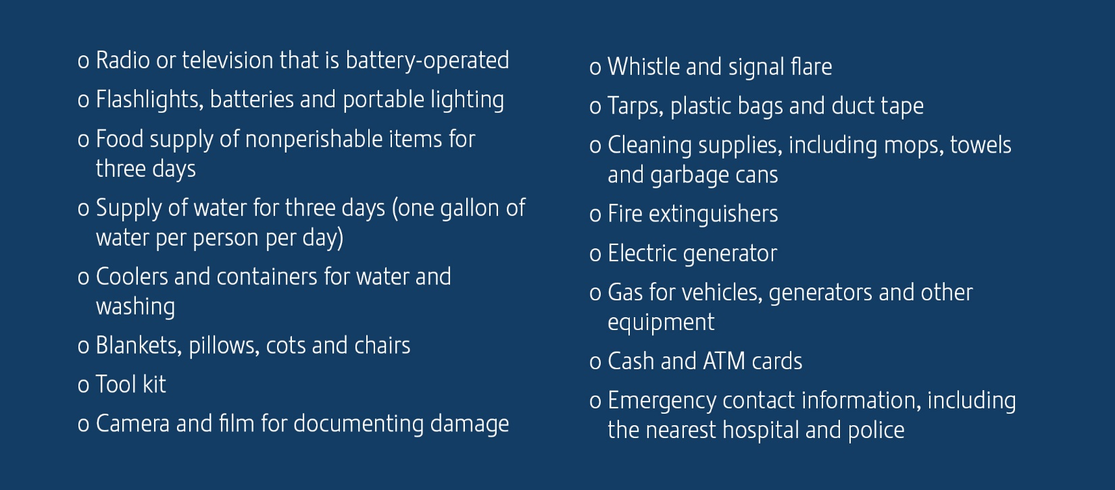

- Develop and familiarize yourself and your employees with an evacuation plan. An evacuation plan is imperative for getting anyone on-site to safety. It should include:
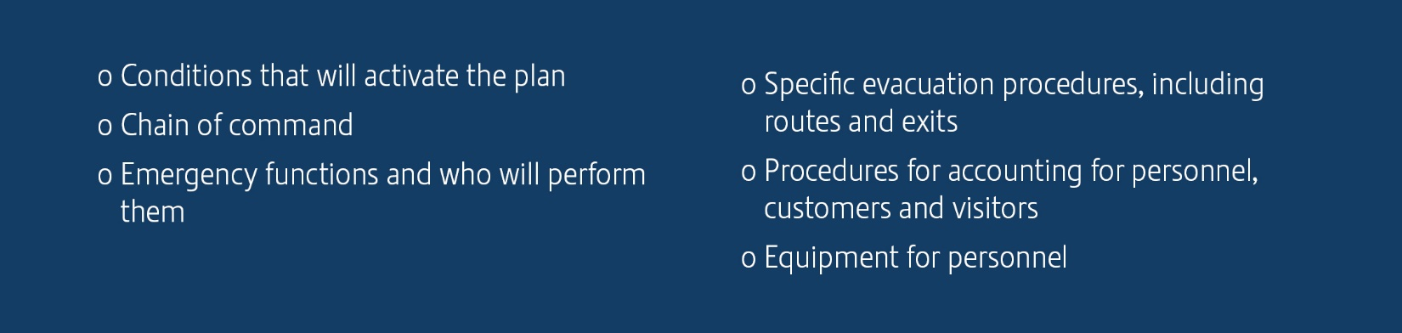



A hurricane watch will be issued 48 hours before hurricane conditions are expected to reach land. Be prepared to act when the watch is issued and protect your physical property from the upcoming storm. Once the National Hurricane Center issues a hurricane watch:
- Track the progress of the storm and monitor its intensity.
- Plan evacuation routes.
- Take pictures of the facility to document any damage that may occur.
- Keep cash accessible, as banks may not be open following the storm.
- Determine if or when your preparedness plan is to be activated.
- Shut down operations, if necessary, and follow established procedures.
Take the following measures to protect the outside of your building:
- Bring yard storage, machinery and equipment into the building, or secure them to prevent them from being blown about by high winds.
- Ensure all roof-mounted equipment is secured to the building’s structural steel, and remove any loose objects.
- Inspect, repair and clear all roof drains to ensure they are able to drain off heavy rains.
- Board up windows and doors with storm shutters or other protective panels.
- Place sandbags outside any opening to your building.
- Test emergency generators.
Take the following measures to protect the inside of your building:
- Move all important documents, furniture and IT equipment away from flood-susceptible floors and away from windows and doors.
- Move hazardous materials, including flammable liquids, oxidizers and toxic materials, from flood-susceptible floors and away from windows and doors.
- Plug or seal floor drains.
- Close fuel valves to nonessential and nonemergency equipment.
- Disconnect power to nonessential equipment.
In addition to securing your facilities, you also have a legal obligation to protect your employees from unnecessary risk of harm. During a hurricane watch:
- Identify which personnel are required to be on-site in the days before and after a hurricane.
- Communicate all areas of accountability and responsibility to key employees. Use your alert system to post status updates and next steps.
- Redirect your phone lines to cellphones, Google voice or backup lines so employees can stay in the know.

- Adjust or decrease operations to prioritize the safety of your employees.

If necessary, evacuation arrangements should be made before the hurricane hits land. If it’s determined that it’s safe to stay on-site during the storm, complete the following:
- Watch for roof leaks, pipe breakage, fire or structural damage, and make repairs as necessary.
- Check the sprinkler water pressure and watch for loss of pressure.
- Turn off electrical switches if a power outage occurs to avoid reactivation before necessary checks are completed.

- Shelter in place, if necessary.

Hurricanes pose a serious threat to the economy when business owners aren’t prepared following a storm. To return to normal operations as quickly as possible:
- Listen to the radio, TV or the National Oceanic and Atmospheric Association to make sure the storm has passed.
- Follow all instructions from local authorities.
- Perform a status check on employees to see if they are in need of help.
- Wait until the area your business is located in is declared safe before surveying the damage.
- Use caution on the roads, and turn around if a road is flooded or barricaded.
- Hire security in the days following the storm, as looting may occur.
- Set up a phone number or website to communicate with employees and customers.
- Take photographs of any damage.
- Contact a professional to survey for safety hazards, including live wires, gas leaks and damage to foundations or underground piping.
- Enforce “no smoking” rules once people are back on-site until it is determined there are no flammable liquid or gas releases.
- Hire contractors to start repairs.
- Contact your insurance agent and carrier.
It may seem overwhelming to create a hurricane response plan, but fortunately, you don't have to do it alone. To learn more about hurricane preparedness practices and specific policies available to you, it’s important to work with a qualified insurance broker. Contact us today to learn more.




HURRICANE
ASSESSMENT
Presented by Wells Insurance

Date: Assessment conducted by:
It can be challenging for a business to recover following a hurricane. In fact, 40% of small businesses won’t reopen after a natural disaster, according to the Federal Emergency Management Agency. As a business owner, being prepared is one of the best ways to ensure your business survives following a hurricane or other natural disaster. This checklist can help you assess the potential damage a hurricane can have on your business.
Assessment |  | Yes |  | No
Does your business need computers, copy machines, fax machines, files, inventory or special equipment to operate? | ☐ |  |  | ☐
Can your business operate without gas, power, water, internet or telecommunications? | ☐ |  |  | ☐
Can your business operate without access to the damaged building(s)? | ☐ |  |  | ☐
If your business income is interrupted, will you be able to meet payroll? If yes, estimate for how long. | ☐ |  |  | ☐
Do your employees commute to work? | ☐ |  |  | ☐
Can the public, your customers and your employees easily access your business (e.g., parking)? | ☐ |  |  | ☐
Do you have communication methods in place to update employees, key customers, vendors and suppliers throughout your recovery? | ☐ |  |  | ☐
Are you able to ship your product or provide services to your customers remotely? | ☐ |  |  | ☐
Will you still have your customers/clients after the hurricane? | ☐ |  |  | ☐
Can your organization survive with reduced or shut-down operations for three to seven days? | ☐ |  |  | ☐
Are your sensitive assets and equipment secured? | ☐ |  |  | ☐
Have you backed up data to a remote location and the cloud? | ☐ |  |  | ☐
Does your business have sheltering plans and evacuation procedures in place? | ☐ |  |  | ☐

For more risk management guidance, contact us today.

HURRICANE -
BEFORE THE STORM
Presented by Wells Insurance

Hurricanes are a serious threat to lives and property. As such, it’s important for business owners to have a plan in place before hurricane season begins or a storm is even predicted. This checklist can help you prepare for a hurricane’s effect on your business, employees and community.

Before the Storm Is Predicted
Protect and duplicate your vital records, including your insurance policies. | ☐
Review your insurance policies to ensure you understand what is and isn’t covered. | ☐
Take photos or videos to document the interior and exterior of the building for insurance purposes. | ☐
Update your employees’ emergency contact information regularly. | ☐
Identify an alternative business site and create a relocation plan in the event the hurricane makes your location inaccessible. | ☐
Back up all data on remote servers and in the cloud. | ☐
Determine safe evacuation routes as well as alternative routes. | ☐
Inspect and make repairs to drains, gutters and flashing. | ☐
Ensure all roof-mounted equipment is strapped or anchored to the roof deck support. | ☐
Install windstorm shutters over windows and doors. | ☐
Replenish your supply of water, nonperishable food, batteries, cleaning supplies and first-aid supplies. | ☐
Have cash on hand since banks may not be open after the hurricane. | ☐
Make sure generator, fire pump and company-owned vehicle fuel supplies are full. | ☐
Test any emergency generators. | ☐
Develop a written crisis management plan for employees. | ☐
Create an emergency response team and define clear roles and responsibilities for each person. | ☐
Conduct regular drills in order to prepare employees for what to do during a hurricane. | ☐
Identify which employees are crucial for operations and make sure they understand what’s expected of them during a hurricane. | ☐
Ensure IT, payroll, benefits and HR functions can operate during and after a hurricane. | ☐
Give employees the necessary equipment and support to perform their duties remotely. | ☐

HURRICANE -
BEFORE THE STORM

After the Storm Is Predicted
Remove as many goods as possible from the floor, shipping them out of the facility, if possible. | ☐
Turn off the natural gas supply. | ☐
Shut down electrical power to sites in the path of the storm. | ☐
Update your company’s website so employees and customers can remain in the know. | ☐

For more risk management guidance, contact us today.

HURRICANE -
DURING THE STORM
Presented by Wells Insurance

If your business operates in a region that is at high risk for hurricanes, it’s your responsibility to take precautions during the storm to protect your property and people. This checklist provides business owners with steps to take during a hurricane to minimize risks.
During the Storm |  | Yes
Move personnel to safe locations. | ☐
Secure all windows, doors and outdoor objects/equipment. | ☐
Give employees plenty of time to relocate. | ☐
Stop nonessential operations 12 hours before impact. | ☐
Communicate with employees and encourage them to take necessary precautions. | ☐
Activate two-way communication channels with employees. | ☐
Patrol the property to watch for roof leaks, pipe breakage, fire or structural damage. | ☐
Monitor any equipment that must remain online. | ☐
Turn off electrical switches during power failure. | ☐

For more risk management guidance, contact us today.

HURRICANE -
AFTER THE STORM
Presented by Wells Insurance

In the aftermath of a hurricane, your business will likely have to deal with property damage. Your priority should be to ensure the safety of your employees and other stakeholders, but these recovery steps can also keep your business safe after a hurricane passes.
After the Storm |  | Yes
Listen to the radio, TV and local authorities to make sure the storm has passed. | ☐
Do not enter the building(s) until the area is declared safe. | ☐
Have the building professionally inspected if you have concerns that any damage could pose a safety hazard to employees or customers. | ☐
Communicate with employees through designated channels. | ☐
Contact employees, suppliers and customers to inform them of any disruptions in operations and an anticipated date when they can expect it to resume. | ☐
Secure the building while repairs are being made or if relocation of business activity is necessary. | ☐
Ensure utilities are restored and in safe working order before resuming business operations. | ☐
Repair and clean your facility to ensure the environment is free of any safety hazards before resuming business operations. | ☐
Enforce “no smoking” rules until it’s determined there are no flammable liquid or gas releases. | ☐
Turn off any natural or propane gas lines that feed into the building(s). | ☐
Secure 24-hour security to protect against looting. | ☐
Consider any financial responsibilities, such as payroll or scheduled payments to creditors. | ☐
Take photographs of the damage. | ☐
Keep detailed records of all expenses incurred during the recovery process. | ☐
Contact your insurance agent. | ☐

For more risk management guidance, contact us today.

